|  |
| --- |
| **Vaccination Culture Calculator Software Requirements Specification Version 1.0 October 1st 2018  Ned Sherman & Mason** **Baird** |

Table of Contents

1.0 Introduction2

1.1 Purpose2

1.2 Definitions, Acronyms, & Abbreviations 2

1.3 System Overview 2

2.0 Functional Description3-4

Main Panel3

Users Panel3

Selection Panel 4

Add Users Panel4

Error Handling4

3.0 System Requirements5

3.1 Hardware Requirements5

3.2 Software Requirements5

4.0 Miscellaneous5

Developer Note5

Contact6

Datasets6

**Revision History**

|  |  |  |  |
| --- | --- | --- | --- |
| **Date** | **Version** | **Description** | **Author(s)** |
| Oct 1st 2019 | 0.1 | Initial Draft | Mason Baird, Ned Sherman |
| Oct 2nd 2019 | 1.0 | * Completion of all sections for current vision of the application * Table of contents | Mason Baird, Ned Sherman |

**1. Introduction**

The United Nations third Goal of Sustainable Development, “Good Health & Well-Being”, encourages people to vaccinate themselves and their family members. Vaccine preventable diseases are still a cause of death even in countries that used to have the deadly diseases under control. Chicken pox, pertussis, diphtheria, and measles are all disease that still cause deaths in the United States (and across Europe). In some cases the death is due to an inaccessibility to vaccination but there is also cases of voluntary refusal to vaccinate leading to death. If the safety and importance of vaccination becomes more widespread fewer deaths could be caused by vaccine preventable diseases.

**1.1 Purpose**

The Vaccination Culture Calculator will be a tool to show a countries acceptance of vaccination so that users can educate themselves on where vaccine acceptance is healthy or unhealthy in the supplied country. The Vaccination Culture Calculator will also provide information for vaccination advocates to get in touch with each other.

**1.2 Definitions, Acronyms, and Abbreviations**

**Front End** – a software interface (such as a graphical user interface) designed to enable user-friendly interaction with a computers

**Back End** - core computational logic of a website, software or information system.

**CSV** - Comma Separated Values

**SD** – Share that Disagree …

**SA** – Share that Agrees …

**SNAD** – Share that neither Agrees nor Disagrees

**VCC** – Vaccination Culture Calculator

**1.3 System Overview**

The three minimum functional requirements for the completed Vaccination Culture Calculator are: [1] the ability to take a country as input and output a summary of the supplied country’s stance on vaccination, [2] the ability to filter columns returned with a checkbox list, [3] the ability to input data into the *Users* table. Additional functionalities (stretch functionalities) include but are not limited to: [1] the ability to view a compressed score derived from the opinion data associated with the supplied country, [2] the ability to view frequent searches, past searches, or searches by user.

**2. Functional Description**

The Vaccination Culture Calculator’s Main panel should have a look and feel similar to the below figure: 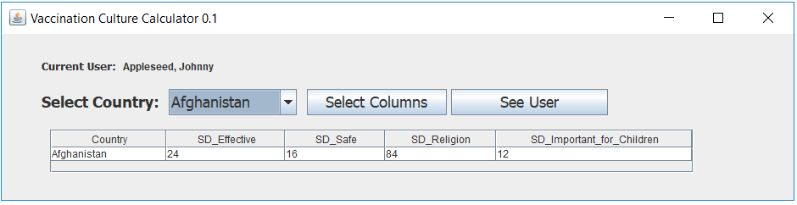

This Main Panel uses:

1. A JComboBox for the user’s seleciton of the country
   1. The comoboBox values will be populated based on the countires availbale in the database.
2. Three Jbuttons
   1. A “Select Columns” button that will link to a new panel where the user can select or deselect the columns they want returned.
   2. A “See Users” button that will link to a new panel where the user can see details about past users.
3. Multiple Labels for the labeling of the country drop down list, current user, display of current user. The number of labels is likely going to change.
4. A JScrollPanel for scrolling through data tables.
5. A JTable for the display of the data in the back end.

The Users Panel should look similar to the below image:

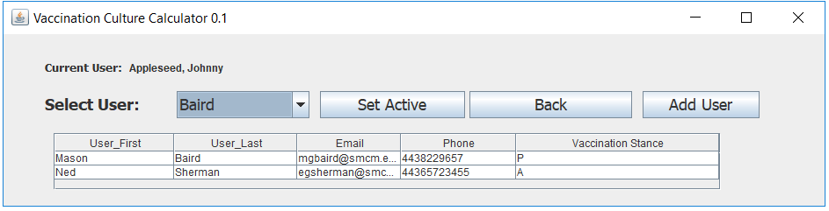

The users panel uses Swing elements similar to the main panel but will pull on different tables from the back end and some of the buttons have different text per their new functions.

The Select Columns Panel will look similar to the below image:

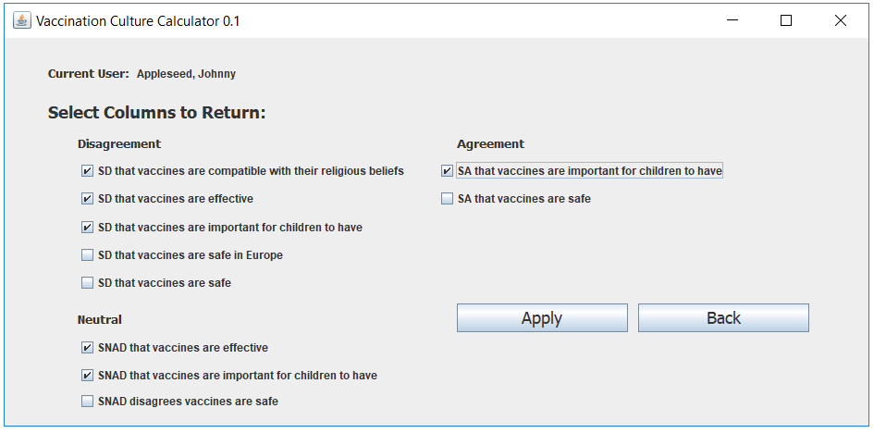

The *Select Columns Panel* should enable the user to select the columns returned on the main panel through the checking and unchecking of check boxes. The panel will involve an “Apply” button that will update the SELECT string sent to the back end and a “Back” button to return to the main panel.

Clicking the “Add User” button from the Users Panel should link to a new Add User panel appearing similar to the below image:

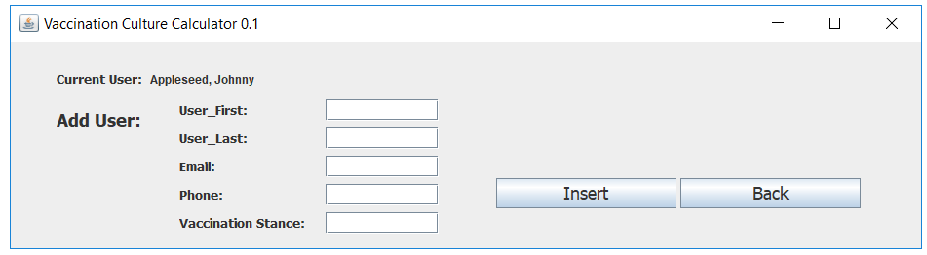

The add users panel should be prepared to take the values entered in the text boxes and create an INSERT string that will be sent to the Users table in the back end.

Error Handling

The final application should be error and crash free. It should be capable of complete data returns even if values are null, it should be capable of handling erroneous input when adding a new user, it should support seamless navigation between the different panels, should not allow for zero columns to be selected, and it should support the changing of the active user. Error handling requirements will become clearer as the application is developed but in general the application should be prepared error and crash free.

**3. System Requirements**

The Vaccination Culture Calculator will not require any specific hardware beyond that of a standard computer. The application will require the hosting machine to be equipped with the software to run a front end Java application, a back end MySQL query-able database, and packages to communicate between these two software entities.

**3.1 Hardware Requirements**

The application will not be hardware demanding and will not require any specific hardware. The application will be suitable to run on any machine with baseline hardware.

**3.2 Software Requirements**

The Vaccination Culture Calculator will need access to the MySQL schema that stores the data on vaccination opinions, be able to run Java, and be able to run MySQL queries. Assuming the application will be used on a machine local basis, its use will require the following programs/software:

1. MySQL Installer – Community (1.4.30.0)
2. MySQL Server 8.0
3. MySQL Workbench 8.0 Community Edition
4. Java 8
5. MySQL Connector J (8.0.17)
6. Java Swing packages

**4. Miscellaneous**

Developer Note

The scope and functionality of the Vaccination Culture Calculator is subject to change. Front end development is often an iterative process that evolves in real time. Some requirements may turn out to be impractical or can be fulfilled with a superior design. An openness to changing requirements will be important until there is a solid understanding of both MySQL and Java’s capabilities and features.

Contact

|  |  |  |
| --- | --- | --- |
| Name | Slack Handle | Email |
| Mason Baird | Mason Baird | [mgbaird@smcm.edu](mailto:mgbaird@smcm.edu) |
| Ned Sherman | Edmund Sherman | easherman@smcm.edu |

The provided example screens are only mock ups. If you can implement a better looking design and maintain each screens functionality, these panels are by no means set in stone. If you have questions about the intended functionality of a screen or how to create it feel free to message either me (Mason) or Ned on Slack or via direct email.

Data Sets

The data sets used in this project so far are available at: <https://github.com/MasonGBaird/450MajorProject>